Appendix 5

The Nelson Schlaft Interview 7/05/07 to 7/08/07 Palmdale, CA

What Nelson had to share (of that which he could recall) is sobering, disappointing, and perplexing. His account of his on/off experiences with E.V. Gray over the seven year period during the 80’s paints an interesting picture of how E.V. Gray might have completely withdrew his novel technology of the 70’s and went on a different but classical route for several years. It seems that he was attempting to promote Cold Electricity Converter technology in 1986 in a bid to sell it in a different application to investors in Israel.

Nelson came on board in early 1981. At that time, all 5 of the motor carts were already built but some of them were missing working power supplies. The frames for the Multi-demonstration cart was already fabricated and partially populated with some components, including the “Start Motor”. The Trigger Cart had some functional power supply installed (Including the strange 5 tap power transformer) but blew out every time it was used. Ignitrons were already in use, however triggered with Thyratrons. Nelson also claims that upon his arrival none of the popping coils would lift off and none of the motors would run. Most of the popping coils were already wound (with finer magnet wire). Also a number of custom 24V to 5KV transistor chopper inverters were already on the shelf. Nelson never did ask what the point of all this was but went to work to solve the technical problems he observed from the vague instructions given to him by his boss. So, a substantial amount of development money (at least a million $$) had already been spent that had resulted in no working devices. Something strange is going on here. Gray was broke in 1979. Where did all this equipment come from unless it was made in the early 60’s. This is certainly a strange set of circumstances from where the story left off from 1976 at the Sportsman’s Lodge media event.

The F-700 Ford custom van was already built to transport all these demonstration carts. So, why was there a huge pre-existing investment in demonstration equipment that was non-functional?

The 60 year old albino engineer, Richard II was definatly a vacuum tube man [my opinion]; Nelson was 40 at the time (born in 1941). Richard II had just had his driver’s license re-instated after receiving some medical treatment that allowed his eyesight to improve enough to pass the state driving test. Apparently he was severely color blind as well. (I wonder how he could read resistor color codes?) Nelson complained that Richard II was constantly “going off on wild tangents” rather than focusing on the job at hand. Nelson’s personal perception of the real task at hand was to make the motors run, make the popping coils pop, and improve the motor power supplies so that they could be installed into automobiles. One example of a wild tangent (as perceived by Nelson) was an event where some kind of spike interference was causing problems. Richard’s solution was to have Nelson go out and buy 50’ of ½” galvanized thin wall electrical conduit. Then have the offending conductors shielded in some kind of plumbers nightmare. Nelson also thought that the use of vacuum tubes for an automobile application was a stupid solution. (True enough, but so were ignitrons)

Some questions that I had at this point were (the responses were typical for all subsequent questions):

1) What were Richard’s background, employment history, and educational credentials? – Response: “Can’t Recall”

2) Did E.V. Gray hold any staff technical meetings (there were 5 employees at the time) to establish and review goals, priorities, preferred procedures, budget? – “No”. So how did Nelson know what the real intent of the project was? Just because he thought the intent was to make a saleable product didn’t make that the real reason for his employment.

3) How long had Richard been working for E.V. Gray? – Response: “Don’t know” [I shall ask Mark Gray]

4) Did Richard share any of his personal history in random shop talk? – Response: “Can’t Recall”

5) What were Richard’s technical reasons for this awkward solution to the spike problem as opposed to using Coax or reducing the EMF interference at its source? – Response: “I don’t know, you couldn’t talk to him about stuff like that”.

Through other conversations it became clear that Nelson, in his past, had almost always worked directly under an engineer while he was employed in the electronics industry. His perception of these many working relationships were much like a military hierarchy where the engineer was the Captain and the technician was the First Sergeant. The engineer gave the orders and the technician carried them out through his own work and by directing the efforts of the helpers under him. Nelson shared several stories about the many “good” and the few “bad” engineers that he had worked for. Working under a “bad” engineer (as such was the case here) was a frustrating and stressful situation.

This particular drama lasted for about two more months or until E.V. Gray pulled the plug and moved the operation to the new location in Canyon Country, CA leaving Richard and the two other helpers behind. Nelson became the engineer (a field promotion?) and Mark Gray the only helper. With Richard out of the picture Nelson could now “make some real progress”. During the following year he implemented these technical improvements:

1) Replaced the under rated diodes (two for each cart) with larger units bought from a vendor in Thousand Oaks, CA.
2) Doubled the KVA rating of the Trigger Cart Power supply by replacing the existing system with two large Variacs connected in parallel and regulated with a series Autoformer (per the vendors recommendations).
3) Eliminated the Thyratron triggering method in favor of the Zener diode approach.
4) Use an ignitron to pulse charge the main storage capacitor. (To provide maximum isolation and “because it worked”)
5) Develop the switching oscillator for the Hover demonstration.
6) Placed a diode in shunt with the popping coils to get them to work, along with some other changes.
7) Developed the tiny projectile addition that popped off the top of the Hover Coil demonstration.
8) Rewired the existing commentators on all the motors to operate with the new ignitron (six each) control scheme. Not all of the existing contacts needed to be used.
9) Develop a scheme to recover back EMF to recharge the storage batteries on the Trigger Cart. (using the negative pulse swing)
10) Design and build the Meter panel for the Multi-Demonstration Cart.
11) Build the logic controllers for the Trigger Cart and the Multi-Demonstration Cart.
12) Build the battery switching solenoid system for the Multi-Demonstration Cart.
13) Upgrade all the connectors to the “Anderson” system.
14) Re-wind all the motor and popping coils to a larger gauge magnet wire (#9 to #12 AWG) so they would work. This modification would lower the coil inductance and therefore increase the pulse current. This re-work was done by a machine shop next door to the second Canyon Country, CA location.

With all these improvements Nelson claims he achieved two major breakthroughs - as compared to his predecessor:

1) The popping coils would now pop.

2) The motors would now run and they could start from a zero speed, unlike E.V. Grays earlier designs that needed a starting motor. (However, Nelson was almost totally ignorant about the Free-Energy characteristics of the 70’s technology)

During the course of these improvements Nelson claims that he disposed of a number of vacuum tube circuit boards and several half-baked unfinished tangent projects that he thought were left behind by Richard II. [Upon further review of this information these vacuum circuits (mostly Thyratron switchings systems) were probably left over from Richard Hackenberger while working in Kalona, KS] So, Richard II’s task was probably to attempt to restore existing equipment with an eye to EMI reduction. Nelson claims that he spent about $250,000 for parts and equipment during his tenure in Canyon Country. I wonder what kind of parts bill Richard II was allowed to run up?

Nelson made all these substantial improvements and he certainly earned his money in the process, BUT, wait a minute. What is going on here? E.V. Gray had essentially handed over a bunch of already built and dysfunctional (not to mention expensive) equipment to a hired outside technician that merrily went along with his appointed task and succeeded in converting all these systems too classical operation. And this is after having gone through the same exercise with a previous employee who couldn’t deliver. We all know that opposing coils will pop and pulse motors will run when enough classical energy is punched through them. But something very big was lost in this translation. Nelson says that the larger popping coil demonstrations operated from a 1600 uF capacitor bank. That is a far cry from the mere 5 uF used in the 70’s. With the use of these larger capacitors, having plastic cores is a moot point since an air core will work just fine at these current levels (and most likely better). Nelsons claims that the current pulse would exceed the range of the Tektronix 4904 scope which maxed out at 1000 Amps. (No doubt)

Just what was the “Fueless Motor” master attempting to accomplish during this time frame? He already had a very functional 10 HP motor in 1972 and a somewhat operable 100 HP motor in 1973, plus a newer version of the same in 1977. He had already been popping some pretty heavy coils for a decade. With the availability of a variety of improved solid state components on the market he certainly had the opportunity to make his equipment even better. So why were all these latest motor designs and popping coil platforms not working in 1981? Why did he have so many expensive custom machined applications already built that didn’t work? It seems that if the first one didn’t function as intended E.V. Gray would have stopped the construction process until the problems were ironed out. Certainly not continue on with four more non-working prototypes. Why was he casting around for some random outside technical expertise to get this stuff going (again?) if he already had the “Secret”? It appears that he had taken a 180° turn from the Fueless technology to a system that was very power hungry. Example: the Hover Coil demonstration eventually took 25KVA continuously to work or 240VAC at 100Amps (that’s as high as the panel current meter would go). The 150 Amp service panel breakers would blow after about 6-10 seconds of operation. The motors, after Nelson got them running, took at least 10 KVA to run with no load (40 Amps at 240VAC). This power also came from the 240VAC power supply (Trigger Cart) because the onboard motor batteries didn’t have a workable converter to provide the huge amount of DC current required to make them rotate. Even if they did, they would have melted under that kind of continuous current draw after only a few minutes of operation. (10,000 Watts ÷ 24 Volts = 416 Amps). Each of the popping coil experiments also took a large amount of stored energy to do their thing. Example: the Shuttle demonstration took 1600uF at 5KV = 20,000 Joules to yield a single 675 ft-lb mechanical impulse. (45 lb load x 15’ of travel)

[Authors Note: It took a while to solve these mysteries, but at the time it was really puzzling]

No wonder, according to Nelson, at least two reviewers that he was aware of (a ranking army officer and a potential investor’s reviewing engineer) on different occasions told E.V. Gray that he was insulting their intelligence by offering them such a ridiculous technology to review. (I certainly agree)

No wonder no motor load testes or COP tests were ever done with this batch of newly modified equipment. Nor were any of the projectiles tested or effectively measured beyond the range of their support rods. In fact, there was little effort to measure any important operational parameter, except what ever Nelson took upon him self to determine. There is a possibility that E.V. Gray already had an effective Military Mortar in 1973 so why was he “re-inventing the wheel”? It seems that E.V. Gray didn’t really care at the time how well this modified equipment worked, just as long as it popped or rotated.

No wonder Nelson claims (and rightfully so) that there was no “Secret” here, just an odd (and wasteful) application of electricity that apparently some people were willing to pay big bucks for, even in its very early developmental stages. Nelson never did question the overall purpose of these efforts or why they were going to be any better than existing technologies.

So what was the game plan here? What happened to the very promising “age-changing” technology that inspired so many early technical investors to split with their hard earned green and stand by E.V. Gray while he was under duress from the LA DA in 1974? Using an obvious 25 KVA to do a 4 second hover demonstration would have sent them all running for the nearest exit door the first time E.V. Gray pulled the switch (after a hearty round of laughter). So what happened between 1977 and 1979 to cause such a sudden shift in the development direction of this new technology?

An obvious analysis would be to conclude that this whole extravaganza, from 1969 on, was bogus from the beginning and the buzzards of reality were finally coming home to roost.

-OR-

For the sake of argument we can consider some of the other anecdotal information that Nelson had to share and possibly look for a deeper set of circumstances to explain these perplexing events of the 80’s.

Here we go:

Consider Nelson’s employment record with E.V. Gray. During the Canyon Country epoch (1981-1982) Nelson was deeply involved with the conversion of a bunch of existing equipment to operate with classical electricity. He never knew how this equipment was originally intended to operate, or what the actual improved advantage was supposed to be. He had no idea what the various motors were suppose to demonstrate or why five of them were needed in the first place. He had to generally make do with the existing equipment (thus the need for the commutator modifications). When this huge task was accomplished to E.V. Gray’s satisfaction the Canyon Country operation was shut down. E.V. Gray moved on to Dodge City while Nelson was laid off. E.V. Gray eventually established himself in Council, ID in 1983 and asked Nelson to return for some summers work. However, this time, Nelson’s new duties were far different than his assignments in Canyon Country. He was now asked to install security systems, hang curtains, and do general handyman type work. Nelson was well trained for all of these duties. The point is that he no longer did any further development work on the motors or the projectile power supplies. Nelson returned for 10 day to 3 month work sessions each of the following three summers (until 1987). When he arrived E.V. Gray handed him a list of chores to be done. When this work was finished Nelson would collect his wages (generally in cash) and return to California. One condition of employment that Nelson insisted on was that he would receive, upon his arrival, a sum of money that covered his round trip travel expenses.

Now let us review what Nelson said about what he was told concerning the “old” technology of the 70’s. Before my arrival, about all he knew was that E.V. Gray’s 70’s technology involved some kind of 9 pole motor. E.V. Gray told Nelson that he was falsely implicated by the FBI in the homicide of some individual who they claimed was the true inventor of the earlier [This appears to be a cover story for the FCC raid] technology. Further more, E.V. Gray claimed that some friends of his came to his aid and raised money to pay for his defense lawyer. Eventually the FBI forbid him to work on this older technology and warned him of severe consequences that would happen to his person should he again engage in this technology. They also let him know that they would be watching him. This was one reason why E.V. Gray was doing business as Home Medical Electronics in 1981. Nelson accepted this story at face value and didn’t question any of the details. I have many reservations and questions concerning E.V. Gray’s account of these significant events. However, something of this magnitude appears to have happened and there may well be some elements of truth in this story. On the other hand Mark Gray simply claims that the 70’s technology was all sold to someone (or group) in 1979. [Actually it had already been sold in 1974 and the probable court cases for control of the patent rights concluded in 1979]

If a sale was consummated then the buyer(s) showed some intelligence by being very low profile and taking only the “Cold Electricity” power converter technology, thus leaving E.V. Gray with a bunch of gutted pulse motors. They most certainly also left him with some kind of very binding non-competition contract. It well could have been a government or big-oil organization. How much money was netted? Obviously, not enough. E.V. Gray certainly didn’t get the huge national (or world) recognition that he really wanted all his life. Apparently he was hooked on the image and life style of the big emerging technology vendor. Perhaps this venture capital raising business was to his personal liking and he intended to go on for a second round? Maybe he really thought that he could find another way to make those motors run and re-sell them to an even higher bidder. Who knows?

Nelson claims that E.V. Gray was not interesting in selling a functional finished product in the first place but rather a “Concept”. Thus, the item for sale was called “The Concept Technology”. “That way, he didn’t have to produce anything”. A concept is worth what someone is willing to pay for it and the liability for its actual performance rests entirely with the buyer. So all E.V. Gray might have needed to do was get a few of those old motors to work in order to make some interesting videos. Perhaps he was banking on his 70’s reputation to find some investor who thought they were getting in on the original Fueless Technology. However, at this stage of the game they would have only ended up with a useless paper “Concept” that would have been cheaper to buy at the local drug store in the paperback novel section. The variations on this theme are many, but there are a few other facts to consider.

Nelson had never seen the 1986 promotion video. From a technical standpoint my interests revolved around the Mark I and Mark II power converters that were shown. Nelson reports that he had no knowledge of these devices. He never built them, tested them, worked with them, or even knew where they came from. He was at a loss to explain the function/operation of the CSET displayed or how the HV was generated to produce the pulsing arc. So, we might well consider what Nelson’s assessment was based upon his viewing of this video for the first time, “That’s Gray’s junk”. It well could have been. It could have also been the revived converter technology of the 70’s. If so who put it all together for him? It was well beyond E.V. Gray’s electronic ability. But, E.V. Gray had many components and converters custom built by a long list of vendors in the area that he had done business with. So, if he had a schematic there were many places he could go and have the converters built, either complete or in sub assemblies. It is for sure that Nelson was “cut out of the loop” on these later developments (or rather possible re-introduction). Was E.V. Gray displaying more fake eye candy (again) or was he gearing-up to make a legitimate big sale outside the country in an application not covered (or unable to be enforced) by his 1979 contract? Obviously, not many of the locals of the 80’s were buying E.V. Gray’s new act using classical electricity, at least the way Nelson had finally got it to function.

A more bold speculation is that E.V. Gray’s 1979 sale had a time limit attached to it or perhaps a marketing area restriction. Perhaps by 1986 these restrictions had expired somewhat. Maybe the buyers ran into their own set of problems and folded, thus leaving E.V. Gray a free hand to do what he wanted. Maybe all the modifications that E.V. Gray contracted for in the 80’s were earnest sideways attempts to improve his equipment without ever having to expose the Cold Electricity Converter. He might have justifiably figured that if he could get these demo devices to work somewhat on classical electricity, they would really come into their own when fed Cold Electricity. Actually that wouldn’t have been a bad idea.

What ever the real events were, it looks more and more like Nelson (and Richard II for that matter) were never exposed to the true “Cold Electricity Converter”. They were hired to do a specific set of jobs that were going to advance E.V. Gray’s larger, and possibility ever changing, investment strategy. Nelson was the perfect employee for E.V. Gray. He was honest enough to be trusted with several thousand dollars of cash to make equipment purchases. He was multi-talented and very self directed. He had a knack for solving the technical challenges laid before him. He didn’t ask too many questions, and he was available for covenant part time contract employment. All in all, E.V. Gray was getting a good deal here.
Interview/Meeting Agenda:

7/05/07 Arrive in Burbank, CA 1:35 PM
Rent Car
Travel to Van Nuys to photograph E.V. Gray’s shop on Calvert Street
Find George Gray still working there (see separate report)
Short conversation, shown 30 B&W photos from Jan, 1973 of E.V. Gray and Japanese investors
Drive to Palmdale, CA
Check into Motel 6
Have supper and retire for the evening

7/06/07 Tea at Starbucks
Call Nelson to confirm appointment at 10:00 AM
Drive to his trailer park and meet him at front gate
Go to “Molly’s Café” and talk till 3:00 PM
Drive to his parked bus, 6 miles out of town, but unable to enter, property owner not home
Return to Nelson’s trailer
Photograph Nelson’s components of his pulse motor
View Ben’s Putt-Putt motor videos
View 1986 E.V. Gray promotion video and news clips
Review some of the E.V. Gray documents
Return to “Molly’s Café” for supper (Prime Rib special on Fridays)
Talk until 8:30 PM
Drop Nelson off at trailer court agree to call at 9:00 the next morning
Return to Motel 6

7/07/07 Call Nelson at 9:00 AM

He is not feeling well, reschedule to pick him up at 11:00 AM
Have Tea at Starbucks (different one) and collect thoughts and review information from the previous day
Drive to Nelson’s trailer and pick him up
Go to Denny’s for brunch
Talk till 6:00 PM
Drive to Black Angus for dinner
Talk till 9:30 PM
Drive back to Nelson’s trailer and exchange farewells
Get back to Motel 6 by 11:00

7/08/07 Leave Palmdale by 5:30 AM

Fuel rental Car
Drop off rental car, take shuttle to airport
Fly out of Burbank at 7:40 AM



Nelson Schlaft in 2007 at age 66, photo by author

Appearances:

Nelson Schlaft is a short and thin older bearded man (66) who was alert and talkative despite his health challenges. He met me at the gate of the 1950’s senior’s only trailer park in his electric wheel chair. The name of the park was 1000 Elms even though there were only about 500 Elm trees left surviving the multitude of single wide older trailers and a sprinkling of more modern 5th wheel travel trailers.

I can see why he needs the electric wheel chair. The walk from the car to the restaurant was stressful. The short walk (about 100 yards) from the available parking space at the Black Angus to the front door caused him to start breathing hard. The return trip was even more difficult. It appears that he has lost a lot of his lung capacity since his bout with Pneumonia. He carries a drug ventilator with him and takes about a dozen hits in an 8 hour period. Inside his door of his attached porch is a collection of 12 oxygen bottles. He claims that he no longer needs oxygen, be he also has sudden episodes of fluid filling up his lungs (possibly a life threatening condition). He has a hospital bed where he attempts to sleep upright. He claims that he doesn’t sleep very well. He also suffered from a 1999 heart attack and has one SS stent installed in his chest. He is the poster child of the effects of being a life long heavy smoker.

He said his trailer was a mess and he was embarrassed to have me visit it. He said he did some things to clean it up, but I wouldn’t have noticed. The junk piles on the tables and floors in excess of 16” high were certainly beyond my wide limits of neatness. A majority of the stuff seemed computer related mostly disks, VHS tapes, papers, computer documentation, etc. His kitchen table was covered with about 20 different pill bottles. The room between the kitchen and the bedroom in back was given over to computer stuff. He had a collection of partially assembled older computers cross connected together. A stack of a dozen or so hard drives and disk drives were on the floor. There was some newer equipment distributed within this kludge, like the new 500 GB serial hard drive.

His back yard is piled with boxes of stuff left over from his handyman/contractor days. He also has a motorcycle trailer that he built but no motorcycle. He owns three vehicles that are parked out back. His lean-to porch addition appears to be a shop. There is a drill press there and two benches stacked high with tools and unfinished projects. Various hardware and garage items are stuffed and stacked in this 12’ x 40’ space.

Nelson’s brother and sister bought him the trailer house as a gift. He is living on SSI, California Welfare, food stamps, and some kind of state rent relief program ($340 a year). His trailer court rent is $204 a month. He certainly didn’t plan for his retirement in any tangible fashion.

Nelson blames his messiness on his depression. Oh, well I’ve seen a lot worse from people who had a lot better health. The most promising part was that the piles of papers were not also mixed with empty beer and wine bottles.

He did have a number of Tupperware containers filled with large candy single life savers. Apparently these were used to help him give up smoking. It seems that they worked.

The Harsh Reality of a Failing Memory

I brought my new 130 hour Sony digital voice recorder ($60.00 from Best). After about 3 hours I shut it off and put it away. There wasn’t enough technical detail in Nelson’s accounts to worry about recording. It was getting frustrating asking questions that were all responded with “I don’t recall”. I really think he was trying; I didn’t detect any attempts to withhold any information. It just wasn’t there. I found him about 5-10 years too late. Given his condition I’m grateful I got what I did.

I thought that having photos and a sketch pad would bring back memories, but it didn’t. We attempted to draw the basic switching scheme that he had developed for the Trigger Cart. He got as far as the shunt diode and the parallel popping coils. After that he was lost. I was attempting to understand how the back end battery was inner connected. There was a diode involved, but he couldn’t connect the wires. He couldn’t figure it out. He made several partial attempts but kept erasing what he wrote and finding technical reasons why his scratching wouldn’t work. It is stressful to witness this condition first hand. We made two attempts on the switching system, one each day. We also attempted to recover the wiring used to operate the motors. This was even more complex since six ignitrons were involved. He couldn’t recall the internal structure of the commentators or the number of contacts he did or didn’t use. He couldn’t recall if the ignitrons fired all together or sequentially.

Looking at the photos was even less helpful. I asked a number of questions about what the function of certain components were. After all if he built it he should have known. But he didn’t. I also enquired about the construction of the popping coils and what function was of the wide cylinders of excess plastic coil form. He didn’t have a clue. Apparently that’s the way they came.

[This later turned out to be a helpful clue]

Perhaps this kind of interview is not productive with a mind in this condition. Maybe he could have done better if he had a shot of oxygen. Hours of chit-chat didn’t seem to work either.

He certainly couldn’t give me what he didn’t have.

The School Bus and the Documents

On the first day we drove to the parked school bus (about 6 miles out of town), but didn’t attempt to jump over the two fences to get to it. I doubt if Nelson could even attempt such a task. The white 1955 bus was parked in the back yard of this ½ acre fenced lot with a modest Forest Green house in front. There were no dogs. Nelson had lived across the street prior to his medical challenges. The bus was now parked on a woman friend’s lot and she was working. She would be off the next day, Saturday. Nelson said he would call and make arrangements to have the gates opened, but I don’t think he did.

The next day he announced that it was too hot to be digging around in his closed school bus. Given that the temperature had reached 113° on Friday it was a reason that sounded pretty good. The suggestion of doing a search in the evening didn’t meet with a positive response either. However, I think the real reason was that he realized that he didn’t have the memory capacity to find a few papers that were probably lost in mountains of trash in his bus (like his trailer). He probably just wanted to spare himself the additional embarrassment of having to look for a long time and come up empty. Maybe my arrival convinced him that what he had might be of some value after all and he didn’t want to disclose them without considering other options?

I was certainly disappointed after having come all this distance, and at no trivial expense, primarily to copy these documents and be told it was to hot out. After all he had assured me that they were accessible and that he would have them available upon my arrival. Well, what can I expect for free? By the end of the second day it was becoming clear to me that the documents didn’t matter anyway. Nelson was never exposed to the Free Energy secret in the first place and what ever he had documented was just a classical solution to a power switching problem. I can do that (and probably better) with out paying for a plane ticket and taking three vacation days.

In hind sight, Nelson’s current ability to carry out any minor commitments (like making a simple phone call) is already compromised. It is highly unlikely that he will ever recover these documents. Like the rest of this technology it is lost, or soon will be.

Some of Nelson’s Job Experience’s

While Nelson couldn’t recall technical details about his work with E.V. Gray he certainly could ramble for hours about his pervious work experiences. In fact 80% of our discussion was me listening to his ramblings. He didn’t ask me many questions. He didn’t want to know what I had done in this area or why I wanted to know what he knew. He wasn’t interested in Gray’s 70’s work or what the basis was for my contention that he was on to an age changing technology. He just wasn’t to reminisce, which I guess is typical of old men on the brink of oblivion. I’ll probably be there soon enough myself.

Outside of the military, Nelsons electronic experience was largely developing early computer interface testing jigs for security alarm systems. He had lots of stories about his experiences with early Commodore 64 and 128 computers. He also recalled working with a collection of “Trash 80’s”

Differences of Conceptual Models

While Nelson’s skill set was pretty solid in solid state digital electronics his grasp of the fundamental of classic analog physics concerning magnetics and inductors was not quite what I expected. It was like we were speaking different languages. I don’t know what the military taught him, or what he forgot, but attempting to discuss the fundamentals of the theory of the popping coils was strained.

- Nelson firmly believed that an inductor couldn’t store magnetic energy. A capacitor could store energy, but an inductor couldn’t. This is despite my examples that switch mode power supply technology is base upon inductor energy storage, or that a supper cooled electromagnet makes the heart of an MRI machine, or that inductors are used as energy storage devices rather than capacitors in some applications. He couldn’t grasp the idea that all one had to do was allow the current to continue to circulate through the coil and the energy would be stored in the field. The equation that describes the magnitude of the energy storage as a function of current - he didn’t want to hear about. It seems that he is allergenic to equations and “That engineering stuff”.

- He didn’t understand that the current in an inductor couldn’t change instantaneously to an applied change in the voltage. Or that current could only rise linearly with time regardless how fast that voltage pulse was applied. He thought that that the current would change depending upon how fast the voltage was applied, however a little slower than a resistor.

- He thought that the back EMF would cancel the magnetic field. He didn’t realize that the field could reverse polarity.

- He thought that flipping over an air coil by hand would have no impact on its repulsion or attraction to another coil, however switching the polarity of the wires would. He had a difficult time understanding that I had experimented with series coils and had them pop just fine. This was news to him

- He had no idea about the classical model where magnetic flux lines are proposed to be in closed loops and that they have a specific direction. His concept of magnetic attraction and repulsion was similar to an electrostatic model; it might have been the same.

- He knew nothing of the “Right Hand Rule” (or is it the “Left Hand Rule”) anyway the idea that the mechanical forces are generated at right angles to the current flow was a foreign concept to him.

- He went through a circuit for an ignition coil. He could draw the schematic correctly (using the Keetering style), but he didn’t know how it worked or what the purpose of the snubber capacitor across the points was. He knew that removing the capacitor eliminated the spark (actually reduce is potential magnitude by 33%). He knew that the turn ratio of an ignition coil was between 1:100 and 1:200 then he realized that he didn’t have an explanation for how the output voltage could achieve 17KV when basic transformer action would have only accounted for 1,200 or 2,400 volts. (Maximum ignition coil output voltage is limited by internal parasitic capacitance – assuming a properly sized snubber capacitor and a spark doesn’t occur). We then moved on to other subjects.

Needless to say mutually exploring what was going on in the Gray system was not going to be very productive. But these model differences also extended to energy balance equations.

Nelson has the idea that a Battery connected to a motor-generator then connected to a solid state converter could charge the battery and have energy left over. (And he thought Gray was weak in electronics???). So as an exercise I went through the calculations to determine watts in and watts out according to his parameters for his proposed system. He was very sensitive to these kinds of calculations and didn’t want his system evaluated in the light of basic engineering analysis. He didn’t like the idea of losses inherent in all of these energy conversions (not to mention the battery). He just knew his approach would work and the reason we don’t use it is because Physics says it can’t work. - No wonder he spent more time as a Missionary rather than an electronics technician. (He claims he was turned down for many jobs because he was over qualified)

Oddly enough, when I attempted to explain to Nelson about the reported anomalous energy output of the early “Black Box” as reported by the Cannady interview where 1400 watts of power was being consumed while being supplied from a small motor cycle battery. Nelson responded that is impossible it can’t be done, etc. etc. E.V. Gray sure did keep him in the dark in more ways than one.

Meanwhile back to the design of the Trigger cart. I asked Nelson why the current rating of his huge diode was only 5 amps (as he recalled), even though the measured forward pulse current through the coils exceeded 1000 Amps. “Well, a 24KV volt diode at five amps can handle a lot of power.” I started to explain to him that the PIV rating had nothing to do with the forward current capacity and that multiplying PIV rating times the forward current rating was meaningless, but I backed off and just dropped the issue. By the second day I didn’t bother exploring any more theory speculations. I’m going to conclude that he had a high current diode (maybe as high as 30 AMP), because of its size, and he can’t remember what he did or didn’t have.

For sport I asked Nelson about the engineering reasons why the main HV power transformer in the Trigger Cart had five equal output taps. He thought that this was a normal power supply design and therefore thought nothing of it. This transformer was already installed on trigger cart when he arrived and he thought is was custom made. I differed with him on his assessment. If E.V. Gray needed a straight single phase 5KV power supply then a full 5KV tap would have been cheaper. All of the diodes were connected in series anyway so the cost of the rectifier stack would have been the same. He couldn’t see the difference. Apparently he didn’t have much experience with power supply design or specifications. I was hoping to get into some speculative discussion on this issue. E.V. Gray [actually Marvin Cole] was fond of using multiple power supplies in his 70’s work. Perhaps this transformer was designed to be a replacement for some other kind of DC converter that generated five outputs that may have been connected in series. But he didn’t bit on this issue. He did say that the transformer burnt out once and he had to get it re-wound. The shop he found was able to get the work done fast and for about $380. He thought that if the whole transformer could be re-wound for that price then the cost issue of one vs. five taps was really a moot point. I would have to agree with his argument; however 25 KVA transformers generally have more copper than that, even in the 80’s. With today’s copper prices the cost difference would have really been scrutinized. Nelson also said that there was a 24 V to 5KV transformer on hand that was part of the DC-DC transistor converter that kept failing. He maintained that the primary winding of this design had only 8 turns on the primary, which I don’t doubt. It was intended to operate at 200 Amps at 24 volts or 4.8 KW. This turns out to be only 20% of the power Nelson eventually needed to make things work.

Nelsons Reciprocating Pulse Motor

Some time between working for E.V. Gray Nelson built a pulse motor prototype using an aluminum lawnmower engine block. He knew right where to find the surviving magnets in his outdoor collection of contractor materials. [See Photos] The idea was simple enough. He thought E.V. Gray’s approach with the sliding magnets was silly and that a direct opposition approach would be better. At least we finally agreed technically on something. He wasn’t sure of the gauge of the wire he used be he measured it with a digital micrometer and got readings between .075” and .080”. (It looked like #12 AWG to me). The plan was simple enough, but then came my usual cascade of questions. Why did he have so much plastic on the coil that was attached to the piston? “To give it some meat”, he responded. Well that may be true but it also added additional mass in a location where it would be an energy drag. For some reason this same configuration shows up in E.V. Gray popping coils as well. Maybe he copied E.V. Gray’s coils form factor because they worked. Now the extra plastic on the coil attached to the stationary head was a mirror image of the coil on the piston. There the extra mass didn’t make any difference. I briefly suspected that what he had made supported the idea of the plastic magnetics that E.V. Gray was attempting to sell.

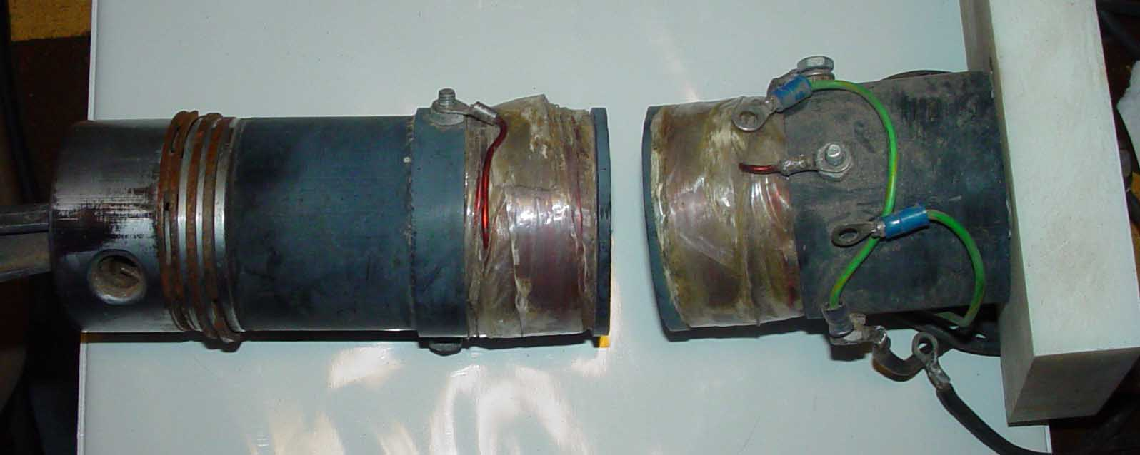

This is a modified lawn mower engine piston using plastic cores for coil forms. Nelson reports that this project ended when he blew out his last power transistor.

Apparently he was going to make a prototype that the two Jewish brothers might have invested in. There was some discussion with them but it didn’t go anywhere. Nelson admitted that his presentation was weak and he didn’t have a clear idea of the business proposal he was presenting. He didn’t know if he wanted to go to work for these gentlemen or contract for a finished working prototype. No deal was consummated. He also blew out the power diodes on the first power up.

Why did he want to build a pulse motor in the first place? What was going to be the advantage over other DC motors? If there was no energy advantage, as he claimed with E.V. Gray’s technology, then what was going to be gained? He responded that it would be a method to make a DC motor suitable and large enough for a car. I responded, “But Nelson, there are already DC motors that go beyond 1,500 HP that are on the shelf and the result of years of advanced engineering and improvement [Such as submarine motors]. With modern solid state speed control systems they are superior to the common gasoline engine and don’t need a transmission.” Nelson’s response was muted but it seemed to revolve around the idea that he was only aware of DC motors that were large enough to operate electric golf carts and wheel chairs.

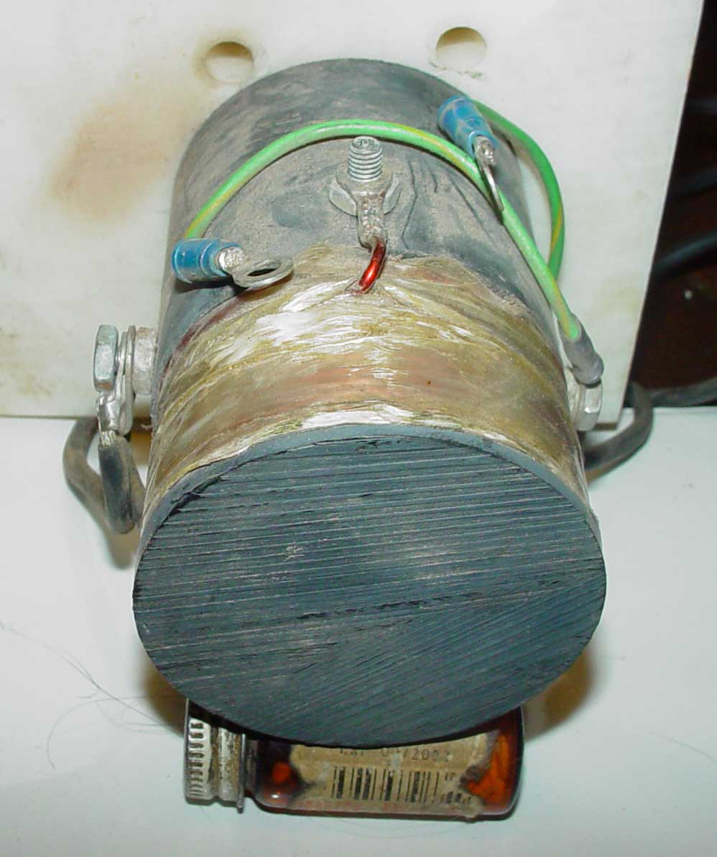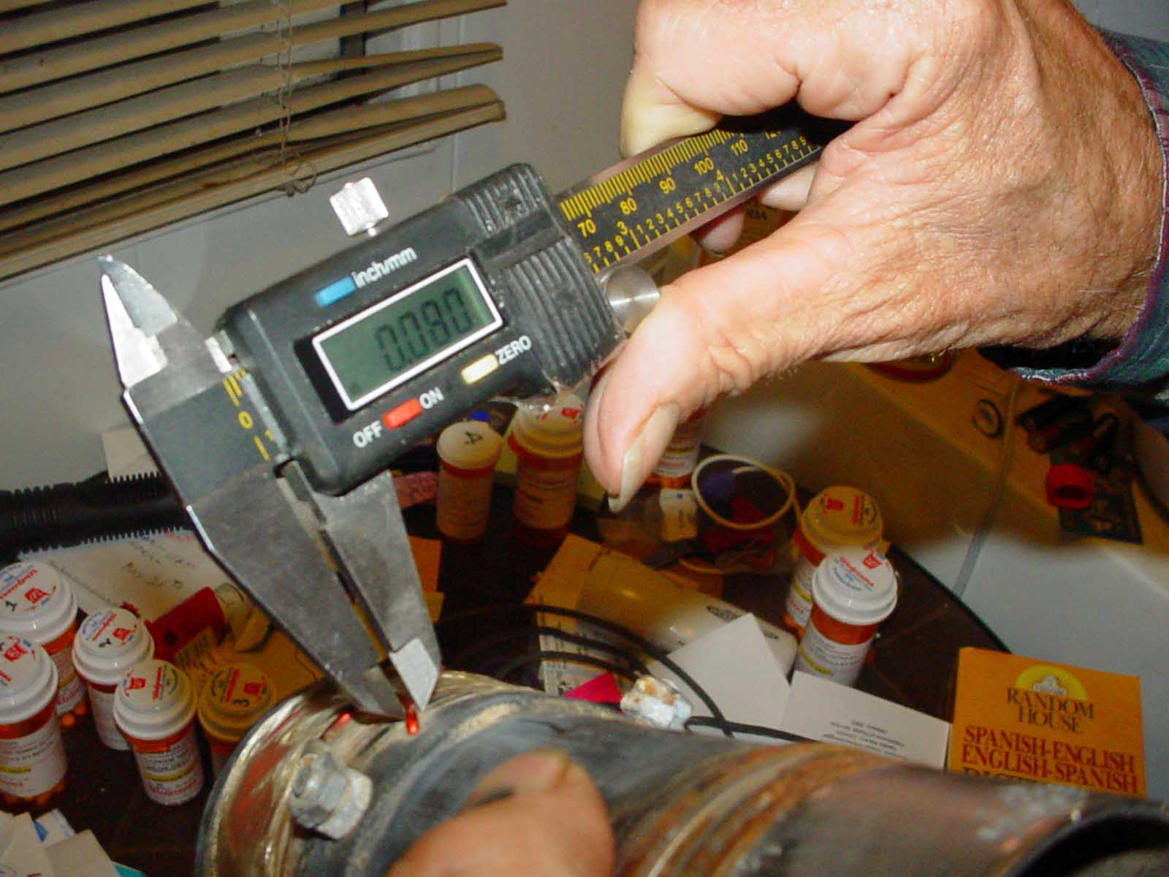

Views of Nelson Schlaft’s prototype Lawnmower engine using opposing coils

I suspect that the real reason Nelson built the opposing repulsion motor was that it was superior to E.V. Gray’s system, or so he thought. If the two Jewish brothers were paying E.V. Gray the big bucks to drag his feet on the delivery of a silly design, then this improved approach should have made their day. Nelson apparently had no clue as to what the real issue was. E.V. Gray’s motors offered Free Energy – however he achieved it. Nelson’s improved motor offered nothing. Nelson appears to have been clueless as to the real technology brokering that was going on and that had gone on for some time.

Conclusion

I knew that when I went down there I might come back empty handed. However, the potential “Jack Pot” was still worth the expense. Unfortunately it was a dud. I learned a lot more about the E.V. Gray drama but “zip” in the technical department to help us recover the construction details of the “Cold Electricity Converter”. And I thought we were getting so close to putting this puppy to bed.

[Authors note: This experience was very disillusioning and resulted in a real slowdown in additional E.V. Gray research for a couple of years. After a lot of pondering the realization came that it was the FCC who had put an end to the engine development in 1979 – not the FBI. But, the FBI was the armed enforcement service who carried out the raid. Now the pieces started to fall into place and made plausible sense with other details that Nelson had provided. If the FCC got involved then something big must have happened to generate a very noticeable EMI signature – and not just some RF hash from a bunch of arcs. A warning would have been appropriate, but a raid would imply a very powerful outburst. After this theory was developed additional information came along to help determine what had happen and when – see Appendix 1]

